Week 11 Lecture 2

Previous Lecture
- Stack & Queue by linked lists

Today’s Lecture
- Lists by linked lists

Unsorted List as Linked List

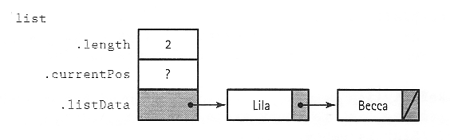
Node Element of Unsorted List

template<class ItemType>
struct NodeType
{
ItemType info;

NodeType *next;
}

template<class ItemType>
class UnsortedType
{
public:
UnsortedType(); // class constructor
~UnsortedType(); // Class constructor

bool IsFull() const; (?)
int LengthIs() const;
// determine the number of elements in the list
void MakeEmpty(); (?)
void RetrieveItem(ItemType& item, bool& found)
// Retrieves list element whose key matches item’s
// key
void InsertItem(ItemType item); (?)
// adds item to list
void DeleteItem(ItemType item);
// Deletes the element whose key matches item’s key
void ResetList();
// Initializes current position for an iteration
void GetNextItem(ItemType&);
// Gets the next element in list

private:
NodeType<ItemType>* listData;
int length;
NodeType<ItemType>* currentPos;

};
template<class ItemType>
UnsortedType<ItemType>::UnsortedType()//Class constructor.
{
length = 0;

listData = NULL;
}

template<class ItemType>
bool UnsortedType<ItemType>::IsFull() const
// Returns true if there is no room for another
// ItemType.
{
NodeType<ItemType> *location;

location = new NodeType<ItemType>;
if(location == NULL)
return true;
else {
delete location;
return false; }
}
template<class ItemType>
int UnsortedType<ItemType>::LengthIs() const
// Post: Number of items in the list is returned.
{
return length;
}

template<class ItemType>
void UnsortedType<ItemType>::MakeEmpty()
// Post: List is empty;
{
NodeType<ItemType>* tempPtr;

while(listData != NULL) {
temPtr = listData;
listData = listData->next;
delete tempPtr;
}
length = 0;
}
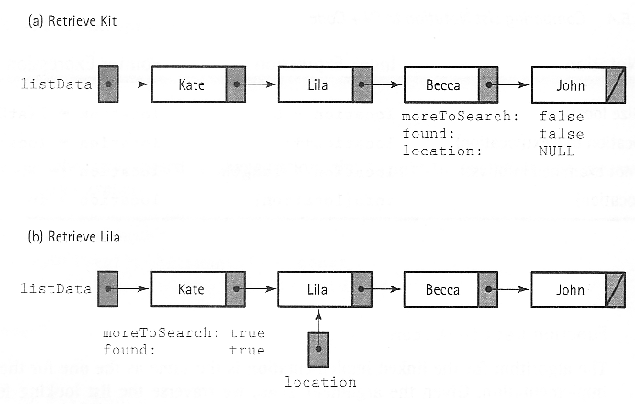
Function RetrieveItem
template<class ItemType>
int UnsortedType<ItemType>::RetrieveItem(ItemType& item,
bool& found)
// Post: if found, bool=true and item is returned
{
bool moreToSearch;
NodeType<ItemType>* location;
Location = listdata; Found = false;
MoreToSearch = (location != NULL);

while(moreToSearch && !found) {
if(item == location->info) {
found = true;
item = location->info;
}
else {
location = location->next;
moreToSearch = (location != NULL);
}
}
}
Function InsertItem

- Array: end; Linked list: front

template<class ItemType>
void UnsortedType<ItemType>::InsertItem(ItemType item)
// Post: item is in the list, length incremented
{
NodeType<ItemType>* location;

location = new NodeType<ItemType>;
location->info = item;
location->next = listData;
listData = location;
length++;
}
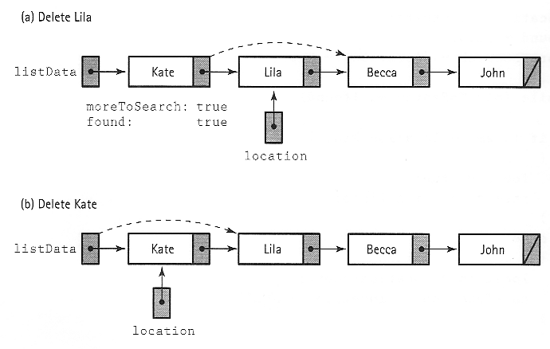
Function DeleteItem
template<class ItemType>
int UnsortedType<ItemType>::DeleteItem(ItemType item)
// Post: remove the element matched with item
{
NodeType<ItemType>* location = listData;
NodeType<ItemType>* tempLocation; // for deleting
If(item == listData->info) {
tempLocation = location;
listData = listData->next; // delete first node
}
else {
while (!(item==(location->next)->info))
location = location->next;
// delete node at location->next
tempLocation = location->next;
location->next = (location->next)->next;
}
delete tempLocation;
length--;
}
Functions ResetList and GetNextItem

template<class ItemType>
int UnsortedType<ItemType>::ResetList()
// Post: current position has been initialized
{
currentPos = NULL; (?)
}

template<class ItemType>
int UnsortedType<ItemType>::GetNextItem(ItemType& item)
// Post: current position has been initialized
{
if(currentPos == NULL)
currentPos = listData;
else
currentPos = currentPos->next;
item = currentPos->info;
}
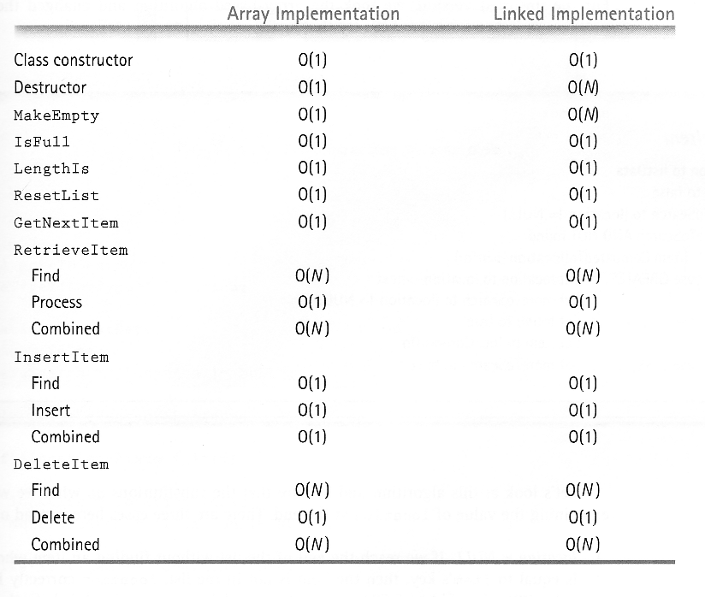

Sorted List as Linked List

- RetrieveItem
- InsertItem
- DeleteItem

template<class ItemType>
void SortedType<ItemType>::RetrieveItem(ItemType& item, bool& found)
{
bool moreToSearch;
NodeType<ItemType>* location;
location = listData; found = false;
moreToSearch = (location != NULL);
while (moreToSearch && !found) {
if(location->info < item) {
location = location->next;
moreToSearch = (location != NULL);
}
else if (item == location->info) {
found = true;
item = location->info;
}
else
moreToSearch = false:
}
}
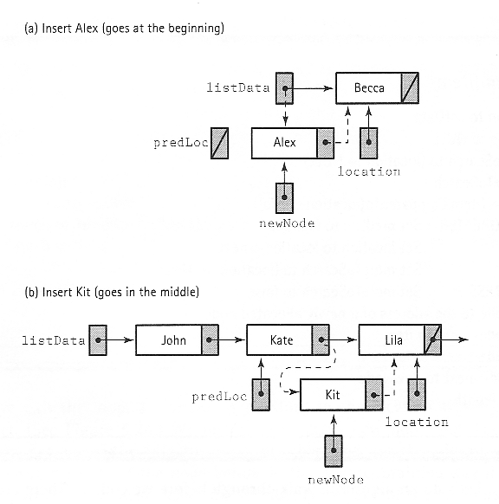
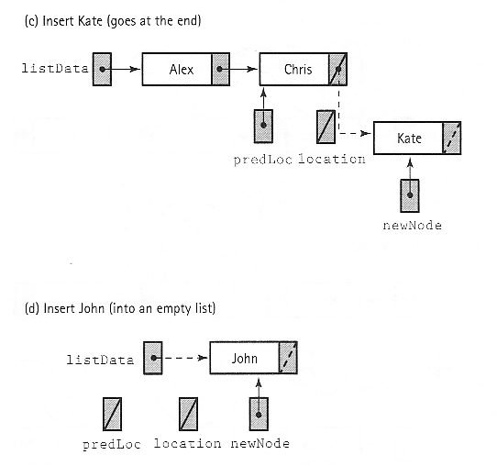
template<class ItemType>
void SortedType<ItemType>::InsertItem(ItemType item)
{
Nodetype<ItemType>* newNode; // pointer to new node
NodeType<ItemType>* location; // traveling pointer
NodeType<ItemType>* predLoc; // traveling pointer
bool moreToSearch;

location = listData; predLoc = NULL;
moreToSearch = (location != NULL);

while (moreToSearch) { // find insert point
if(location->info < item) {
predLoc = location;
location = location->next;
moreToSearch = (location != NULL);
}
else
moreToSearch = false;
}

// prepare node for insertion
newNode = new NodeType<ItemType>;
newNode->info = item;

// Insert node into list
if(predLoc == NULL) {
newNode->next = listData;
listData = newNode;
}
else {
newNode->next = location;
predLoc->next = newNode;
}
length++;
}

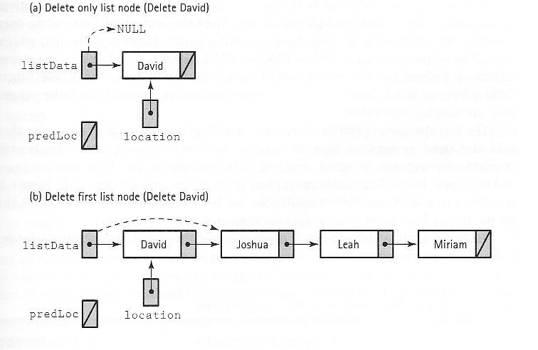
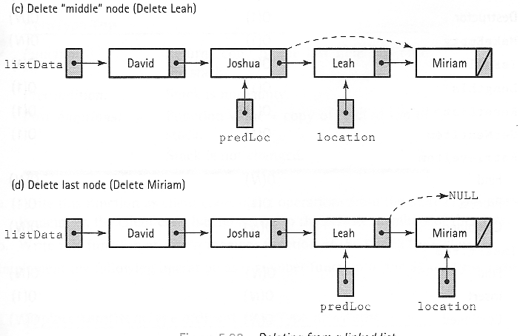
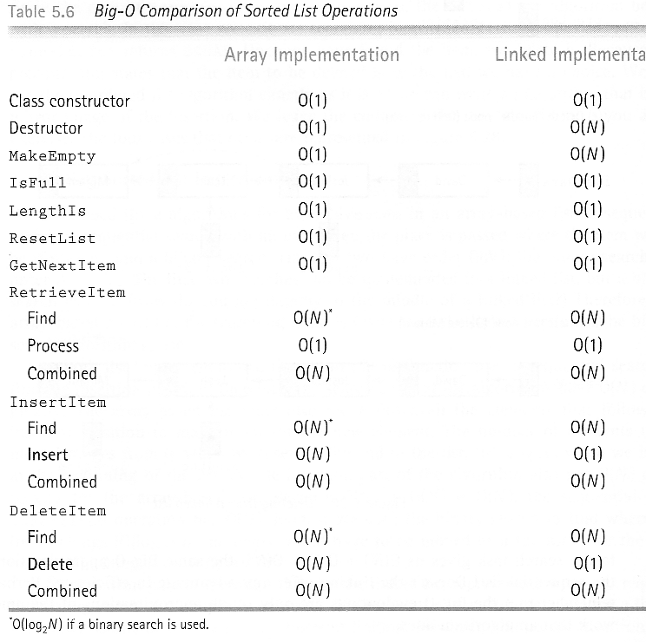
Polymorphism

One of the greater advantages of deriving classes is that a pointer to a derived class is type-compatible with a pointer to its base class. This section is fully dedicated to taking advantage of this powerful C++ feature.

// pointers to base class
#include <iostream.h>

class CPolygon {
protected:
int width, height;
public:
void set_values (int a, int b)
{ width=a; height=b; }
};

class CRectangle: public CPolygon {
public:
int area (void)
{ return (width * height); }
};

class CTriangle: public CPolygon {
public:
int area (void)
{ return (width * height / 2); }
};

int main () {
CRectangle rect;
CTriangle trgl;
CPolygon * ppoly1 = &rect;
CPolygon * ppoly2 = &trgl;
ppoly1->set_values (4,5);
ppoly2->set_values (4,5);
cout << rect.area() << endl;
cout << sqre.area() << endl;
return 0;
}

Output:
20
10
To make it possible for the pointers to class CPolygon admit area() as a valid member, this should also have been declared in the base class and not only in its derived ones.

Virtual Member Functions

In order to declare an element of a class which we are going to redefine in derived classes we must precede it with the keyword virtual so that the use of pointers to objects of that class can be suitable.

// virtual members
#include <iostream.h>
class CPolygon {
protected:
int width, height;
public:
void set_values (int a, int b)
{ width=a; height=b; }
virtual int area (void)
{ return (0); }
};

class CRectangle: public CPolygon {
public:
int area (void)
{ return (width * height); }
};

class CTriangle: public CPolygon {
public:
int area (void)
{ return (width * height / 2); }
};
int main () {
CRectangle rect;
CTriangle trgl;
CPolygon poly;
CPolygon * ppoly1 = &rect;
CPolygon * ppoly2 = &trgl;
CPolygon * ppoly3 = &poly;
ppoly1->set_values (4,5);
ppoly2->set_values (4,5);
ppoly3->set_values (4,5);
cout << ppoly1->area() << endl;
cout << ppoly2->area() << endl;
cout << ppoly3->area() << endl;
return 0;
}

Output:
20
10
0
What Happened …

area() has been defined as virtual because it is later redefined in derived classes. You can verify if you want that if you remove this word (virtual) from the code and then you execute the program the result will be 0 for the three polygons instead of 20,10,0. That would be because instead of calling to the corresponding area() function for each object (CRectangle::area(), CTriangle::area() and CPolygon::area(), respectively), CPolygon::area() will be called for all of them since the calls are via a pointer to CPolygon.
What Happened …

Therefore what the word virtual does is to allow that the member of a derived class with the same name as one in the base class is suitably called when a pointer to the base class is used.

Today’s Lecture

- Lists by Linked Lists

Next Lecture

- Sorting Algorithms (1)

